**Check the suspension status:**

1. 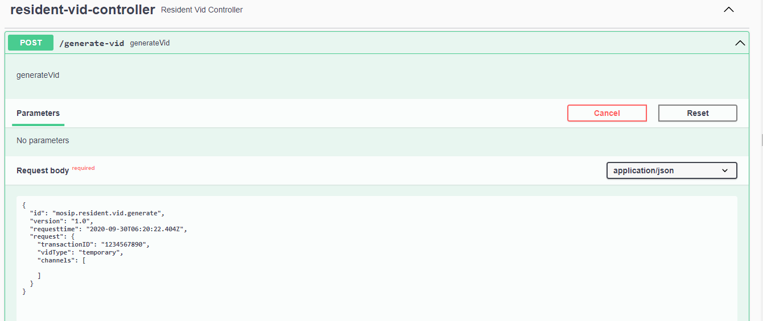Generate a credential.

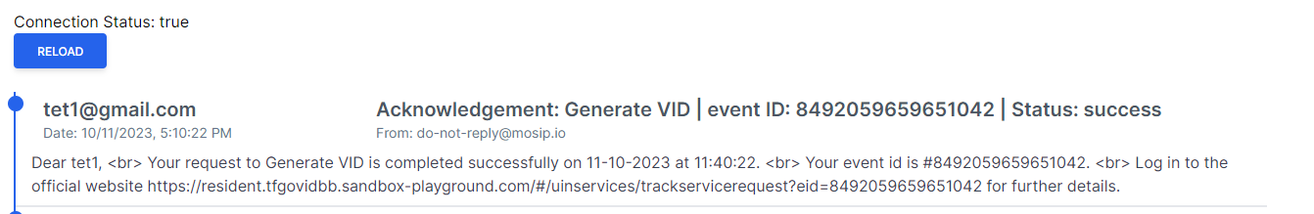Notification:

1. Suspending credential for pre-defined period, if its lost/stolen.

1. Notification

1. Checking status of Credential.

5.Credential gets active when suspension is terminated.

Notification:

6.Checking status of Credential.

